Introduction:

The Simpsons system was created to allow the user to carry out a wide range of tasks to allow the business to complete tasks quicker and more efficiently. The system allows users to insert information into the database regarding different subjects such as customers, staff members, bookings, and many more. Not only can the user insert information into the database, but they can also alter the information and delete records. This is to allow the business to store the information/ make changes within the database which enforces easy access and a secure location, in contrast to previous storing methods (storing information in a filing cabinet).

By using a system to fulfill these tasks, the user can be confident that the correct information will be inserted/ altered correctly and securely by telling the user areas in which invalid data has been entered to ensure the data entered is valid and reliable. As a result of this, it will enforce data integrity as well as increase efficiency as they can insert information immediately which can be accessed as soon as the data is inputted, making the system more efficient for Simpsons to store and make changes to data.

The user will also be able to carry out other tasks such as logging into the system with a desired username and password which will ensure the system is protected, and no unauthorized user can access the system. The user will also be able to access the help form in need of any assistance, and as a result, a PDF will open giving the user directions to solve their issues. The user will also have the choice to select the table of their choice and the action they want to take by using the Menu strip found in the main menu (this can also be achieved in the table select form).

Recommended hardware & Software:

To run the system, we recommend you meet the minimal requirements to have optimal performance, and to ensure the system does not crash whilst it is in use.



To see if you meet the requirements go to:

Settings -> System -> About

Instructions:

Login Form

When you run the system, this will be the first form you are greeted with. You will be able to see a wide range of components such as buttons, pictures, and textboxes to aid you in knowing what data to enter and where. To log into the system, please enter the appropriate Username and Password into the textboxes, a picture of a user will be on the left of the username field, and a padlock will be found on the left of the password field, once completed please click the Login button found below. If you are wanting to see the password you have entered, please hold down on the picture of the eye, found on the right of the textbox, to allow you to see the password you have entered. If the user enters the incorrect data multiple times, they will be locked out and will have to wait before attempting again to ensure no intruders are permitted into the system.

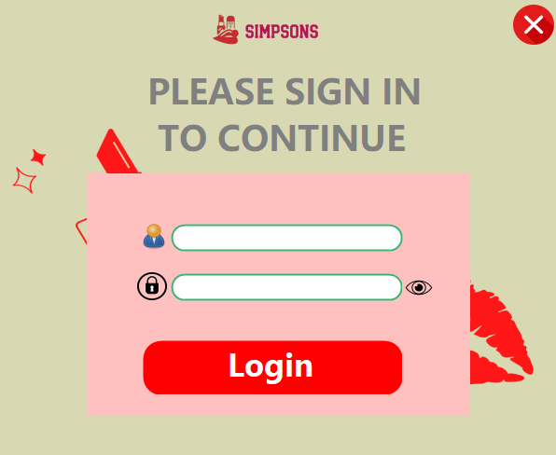

Please Enter Your Username and Password here

In need of seeing your password, please hold down on this picture box

Once you enter your details, please click this button to login

Click here to exit the application

On every form, the user will be provided with a picture box of an “X” which is situated at one of the top corners. The user is then presented with a message box to confirm their choice, and if they request to continue and close the application, the system will stop running. By providing the user with a message box, it gives them the option to decide if they want to exit or not.

To prevent the user from repeatedly attempting to log into an account, I have implemented an account locking feature, when the user gets their details incorrect numerous times (3), they will be presented with an error messaging telling them they have been temporarily locked, once the timer is up, they will be given 3 more attempts. This was created to prevent users from gaining unauthorized access.

Splash Form:

This is the splash form. The user will be redirected here if they can log in successfully, or if they have selected the strand of their choice. The purpose of this form is to redirect the user to the selected form of their choice. They will be able to track how long is remaining until they are redirected by looking at the progress bar. The Simpsons logo will also be shown in the middle of the form to keep it professional but engaging.

Main Menu:

This form is where the user can select what strand they want to use by clicking on a picture box. The user will gain access to the Table select form once they have clicked on the “Cosmetics & Beauty Service” which is allocated towards the top right corner of the form, the Splash form will briefly display before taking the user to the Table select form.

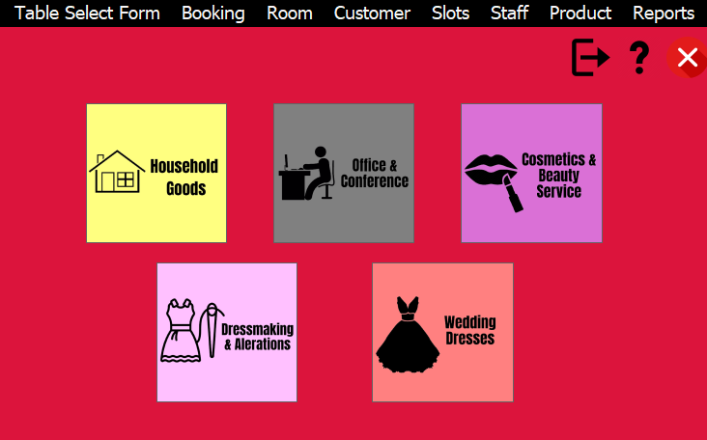

If the user selects any other strand, they will be presented with a message box as the other strands are currently not available for use yet.

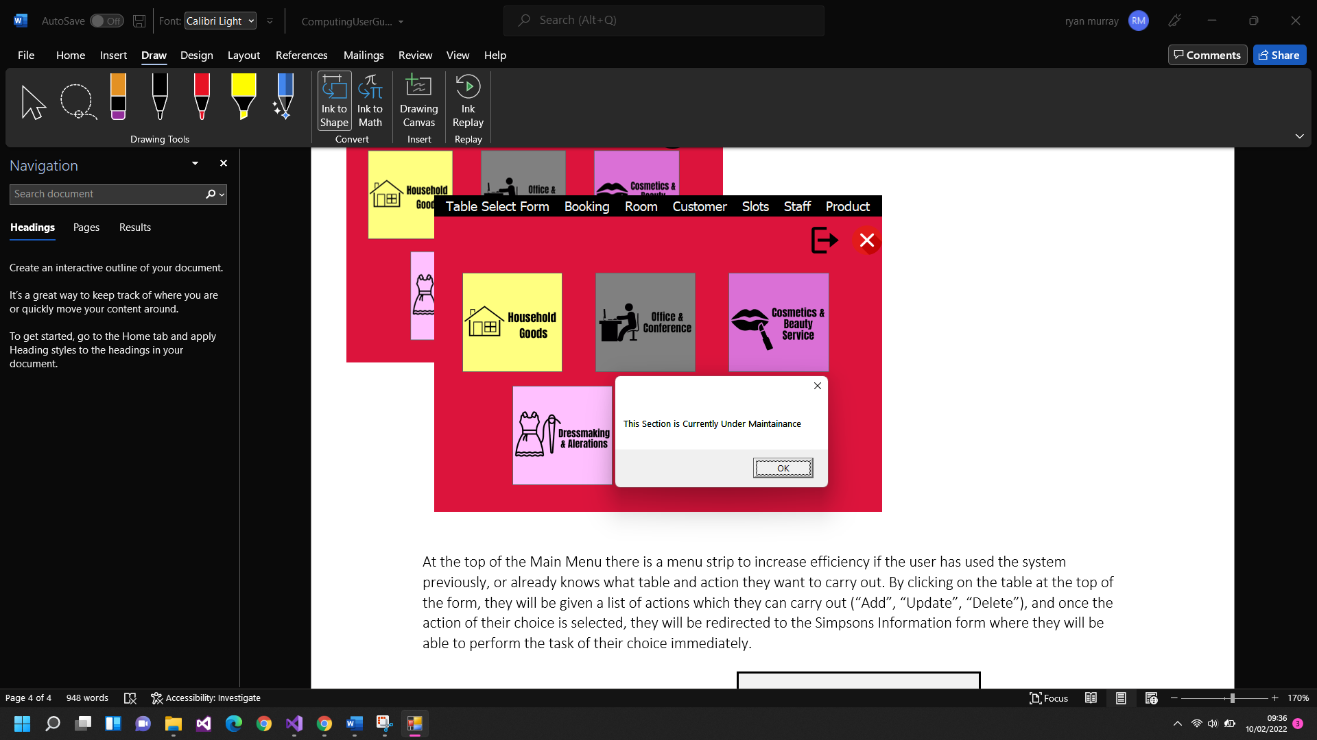

Similar to the Login form, the user can still click on the picture of the letter “X” to allow them to decide to close the system or not, although as the Login form was the first form, they now have the option to return to the Login form by clicking on the image of a door, and similar to the “X” picture box, they will be presented with a message box before deciding if they want to log out or not.

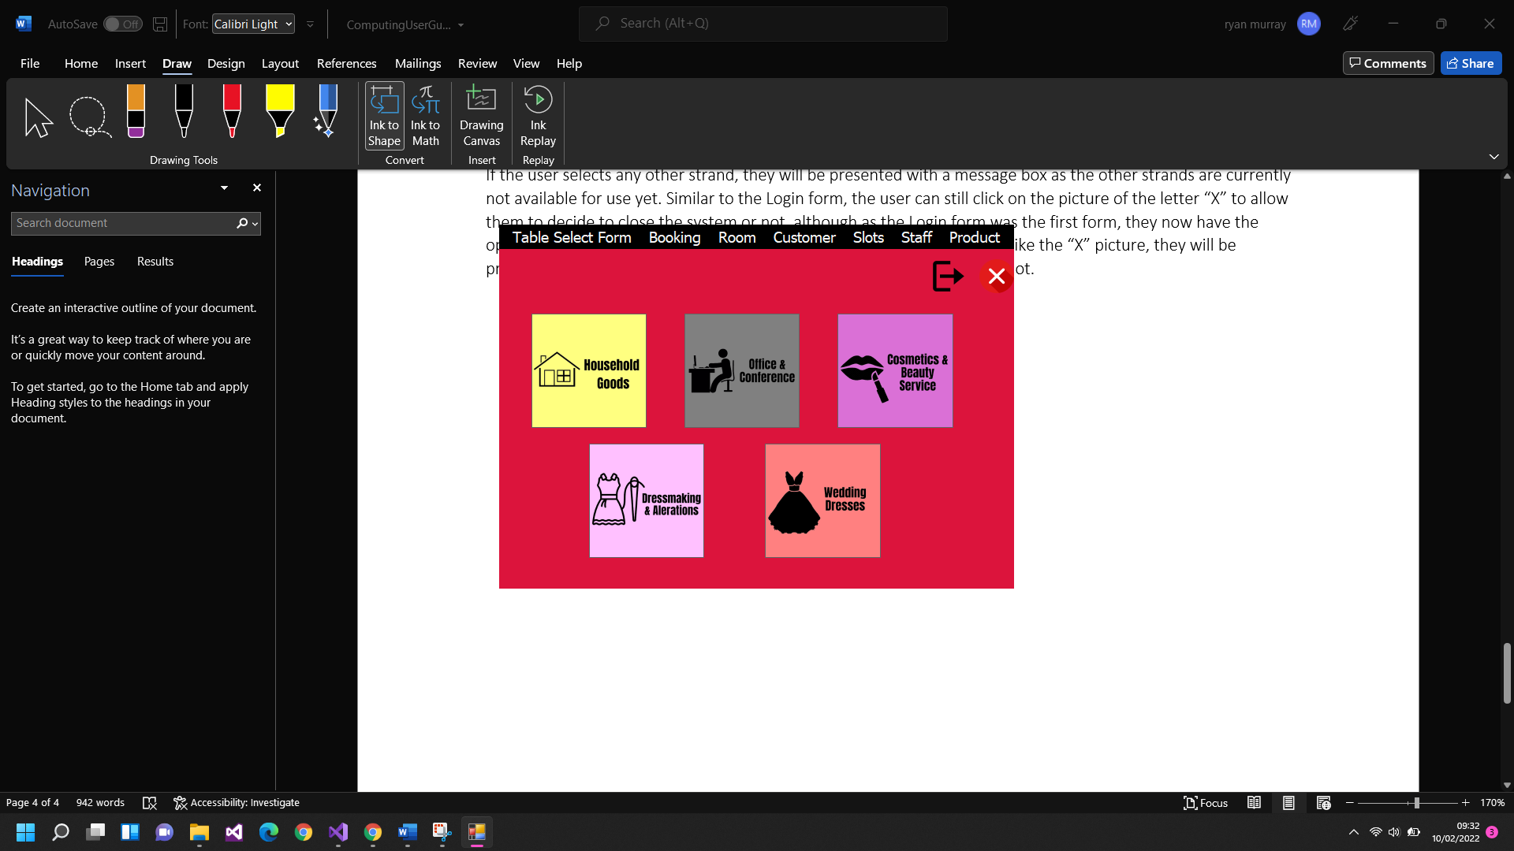

At the top of the Main Menu there is a menu strip to increase efficiency if the user has used the system previously, or already knows what table and action they want to carry out. By clicking on the table at the top of the form, they will be given a list of actions which they can carry out (“Add”, “Update”, “Delete”), and once the action of their choice is selected, they will be redirected to the Simpsons Information form where they will be able to perform the task of their choice immediately.

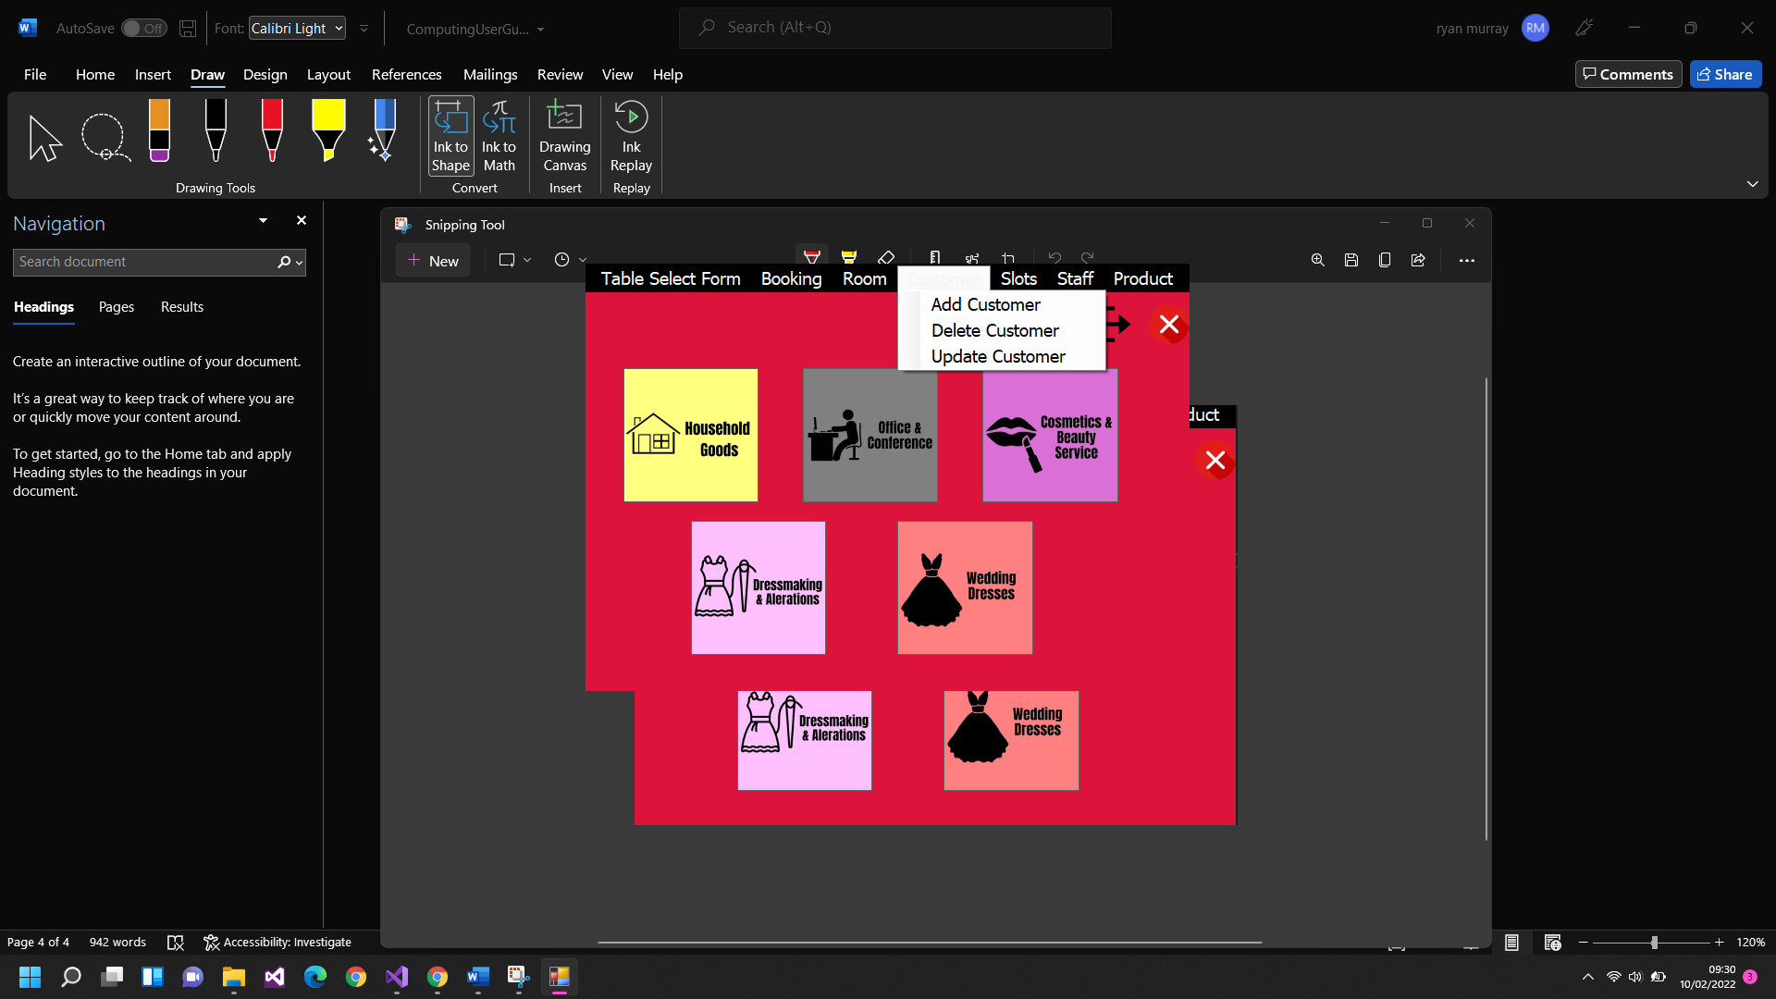

If the user needs any assistance, they can click the “?” picture box which will load the user guide in which contains information on how to use each form. This is also accessible by clicking the “H” key on the keyboard on any form.



Another feature that can be accessed within the Main Menu form is the ability to view reports. When clicking on the Reports header found at the top of the page, a list of available reports will appear and whenever you click on the report of your choice, the current form will close, and the report form will open for the user to view information regarding Bookings.

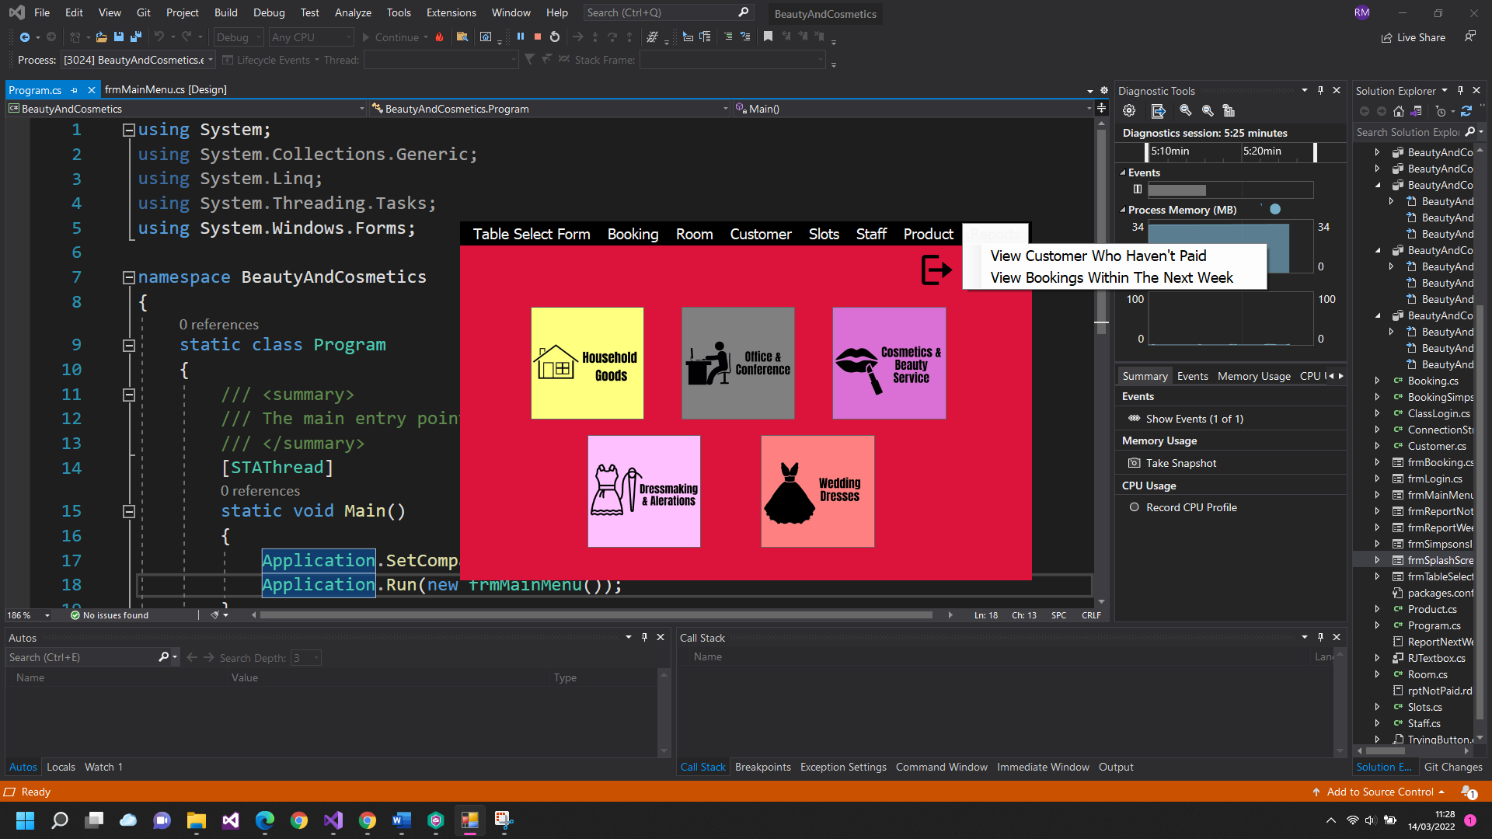

Table Select Form:

This is where the user selects what table they want to use whenever the Simpsons Information forms load, or if the user wants to add a booking, the booking form will open. Once the user is redirected to a form, they will have the option to pick between multiple tables which can be accessed. Once the user clicks the table of their choice, the Simpsons Information form will load, and display the Table of the user’s choice within the Simpsons Information form.

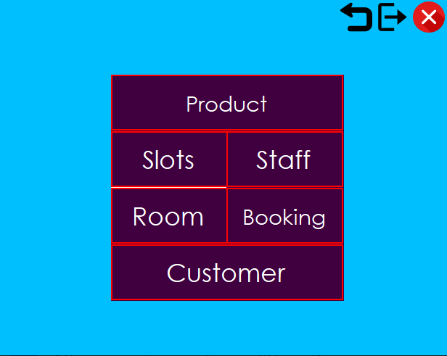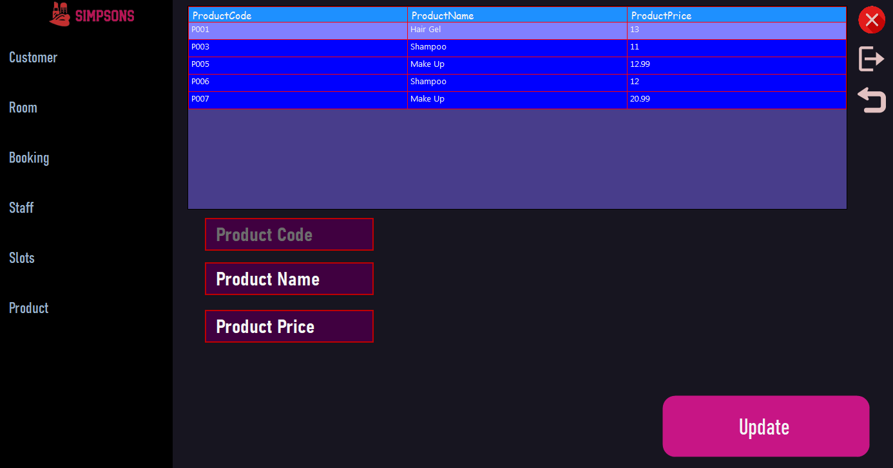

On the Table select form, the user will be able to access the previous functions such as Logging out and exiting the application by clicking on the same pictures seen in the previous forms, but they also have the option to return to the previous form which is the Main Menu. The user will be able to do this by clicking on the picture of an arrow pointing backward and once the user does this, they will be presented with a message box asking if they are sure they want to return to the previous form. This was implemented to increase efficiency and to allow the user to switch between forms quickly.

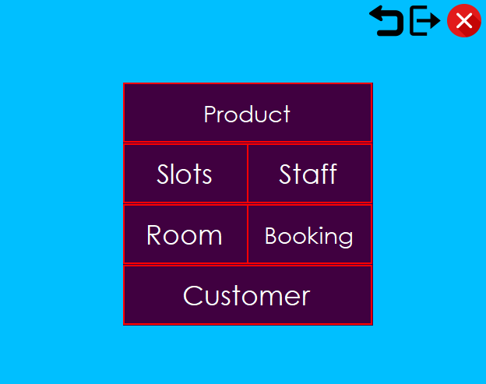

Simpsons Information Form:

The Information form is where the user can access the data for each table within the database. Once the user opens the form, they will have the ability to add, update and delete rows of information within the tables found inside the database, using the selected fields. The information form uses the same components that are found in the other forms such as Logging out, exiting the application, accessing the user guide, and returning to the previous form (uses the same pictures) although I added an additional picture box which allows the user to return to the main menu. This can be carried out when the user clicks on the picture box of a house. Once the user clicks on the picture, a message box will appear enforcing their choice of whether to return to the Main Menu or to remain on the information form.

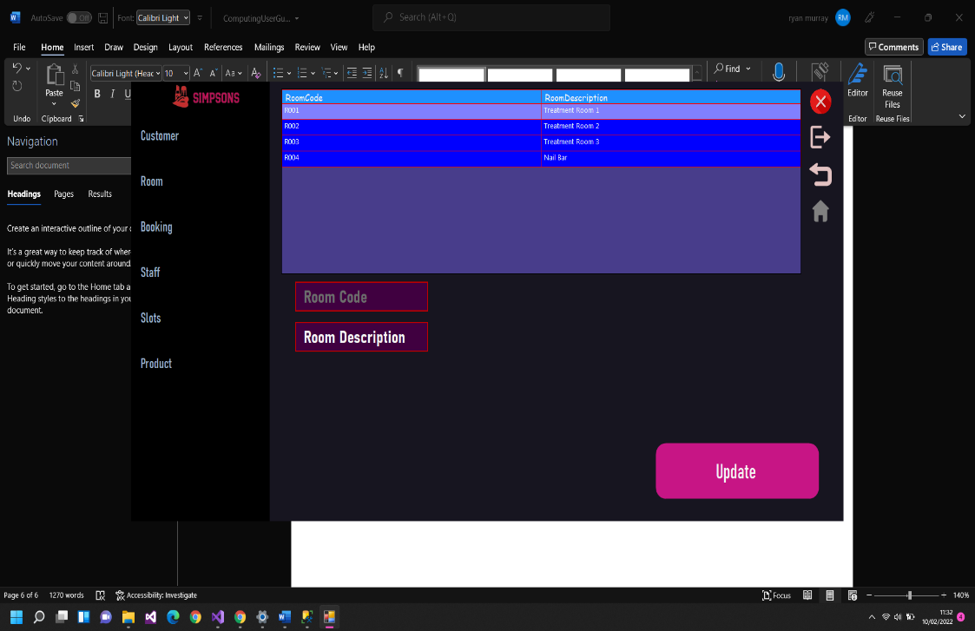

Once the user has selected the table of their choice from either the menu bar found within the main menu form, or from the table select form, the table of their choice will be displayed when the form loads, and when the user is using the menu strip they can select what action they want to carry out regarding the form of their choice, and when the form opens, the appropriate controls, buttons, and features are put in place to ensure the action of the users choice is enforced.

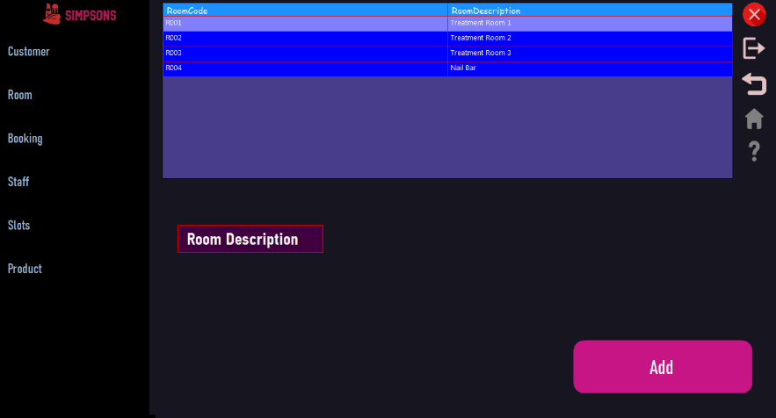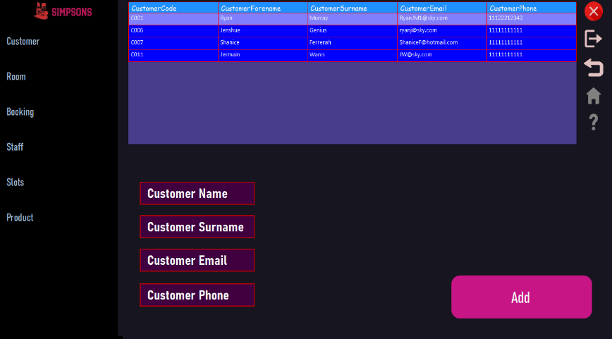

Depending on the table the user decides to view, different textboxes and controls load to assist the user in inputting, deleting, or editing information within the database

Found on the far left of the form, the user can select the table they want to use. Once the button is clicked, a drop-down will appear showing the user the different options for the selected table (Add, Update and Delete, these are the same options for every table). This feature can be carried out for any selected table, and if the user clicks on a different table, the previous table’s dropdown will close, and the new selected table’s dropdown will open. This is to increase efficiency and to make the system look and feel professional.

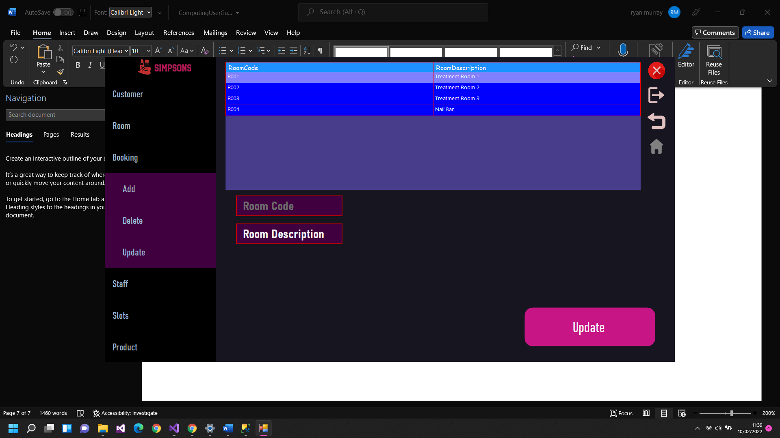

This is where the user selects their table

If the user decided to add a field into any table, the number of textboxes loaded in will vary depending on how many fields of information need to be added into the database. The text found on the button will also change to Add, to allow the user to see what option they have selected. To aid the user in knowing what each textbox is used for, I changed the text for each textbox to relate to the field of information the user will be inputting into the table. In addition, the information from the selected table will load in, and then drop-down will close, making the system feel even more professional.

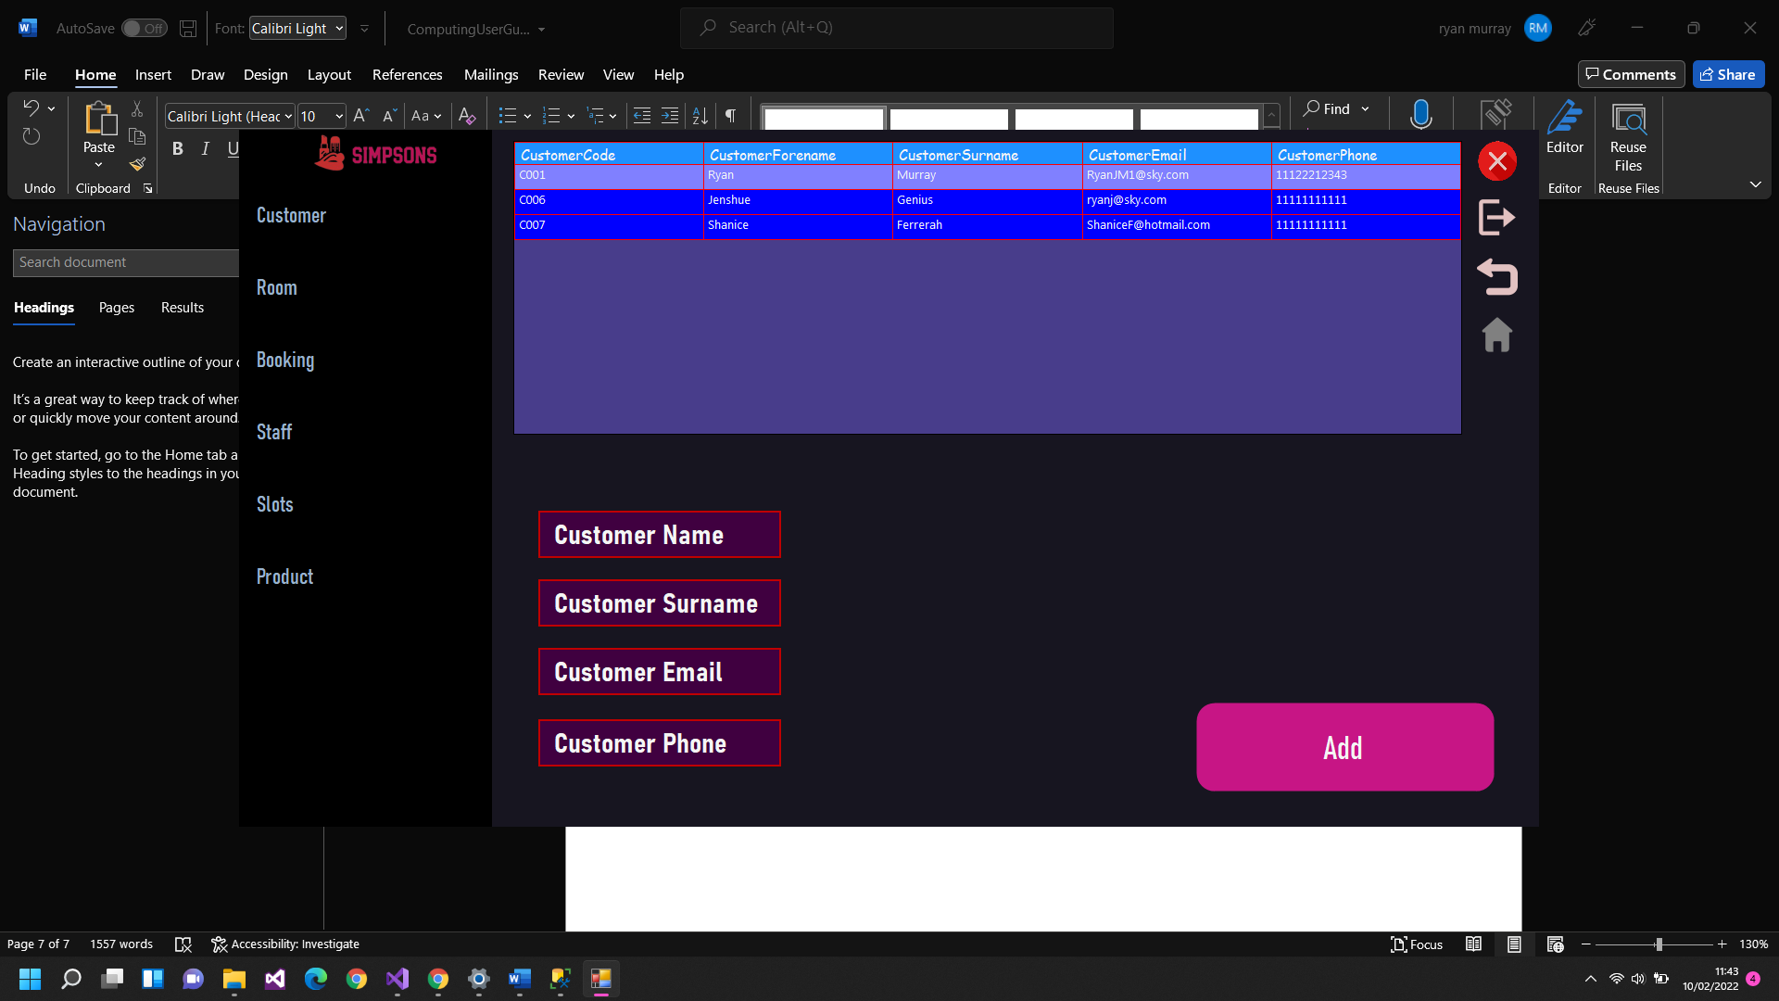

This shows the drop down has been closed, once the user has decided what to do with the data

This is where the user can submit the data

This is where the user enters information for each field (Text is displayed to assist the user in knowing what each field is for)

Once the user selects to add a row of information into the table, they must use the controls to insert the information. Each table will use the same controls (Textboxes) except the booking form, to ensure the interface is simple yet effective.

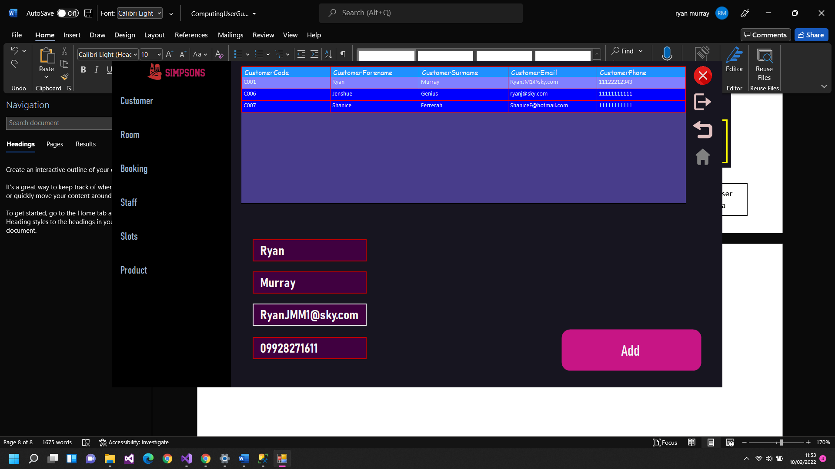

Once the information is entered into the required field, the user must click on the “Add” button to check that the data entered has met the criteria, if the data has not, a message box will show, telling the user what field(s) to correct. This is to ensure that invalid data cannot be entered into the database. If the user does not enter any information into the textbox, they will also receive an error message, as null data is unable to be inputted into the database.

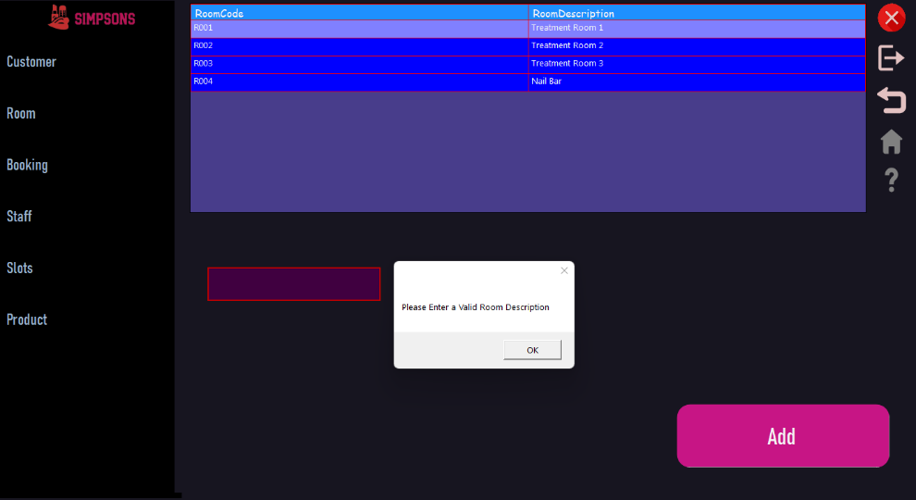

When the user is updating a row of information, the controls (text boxes, etc) are locked as the user is required to select a row of information to update before attempting to update. If the user decides to attempt to update before selecting a row of information they will be presented with an error message, reminding them to select a row of information.

The same validation rules are enforced within the Update section of the form, as they are unable to leave a field null, and if the user attempts to insert invalid data into the textbox, they will be presented with an error message.

When the user is deleting a row of information, they are required to select a row (similar to the update section) before attempting to delete it, although the user is unable to edit the information within each control as it is locked to prevent the users from changing the data.

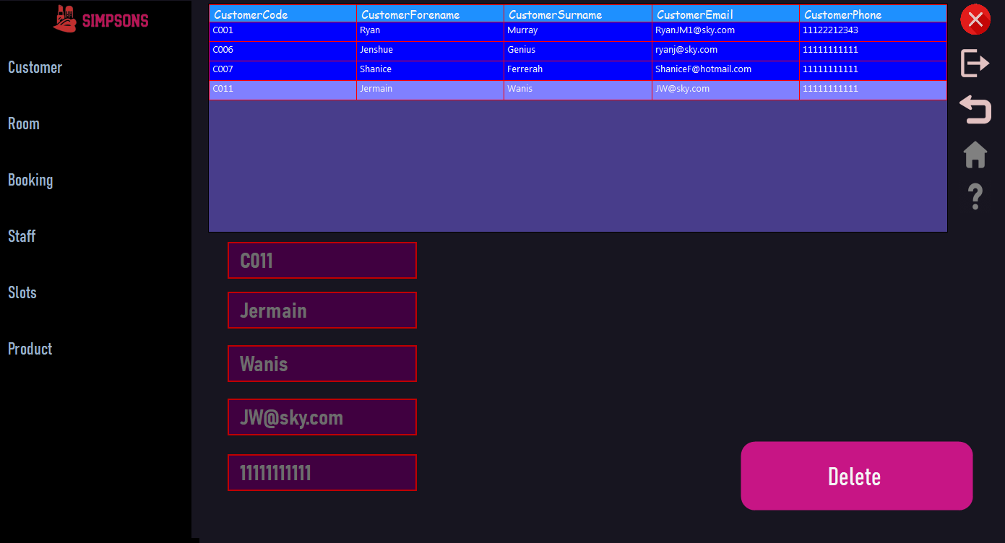

The textboxes are disabled to prevent the user from altering the data

Once the user decides the row of information they want to delete, they must click the “Delete” button to remove it within the database, although the user is presented with a message box confirming their choice.

If the user decides to delete the row of information, the information will be deleted from the database and the data grid view will update, showing the user the information they have requested to be deleted has been successfully deleted

**Booking Form**

When inserting data into each table, the same controls are used (textboxes), and the same validation applies, although when the user is inserting information into the Booking table, they are required to use different controls.

The user can gain access to the Booking form by clicking on the Booking Add button found within the Simpsons Information form.

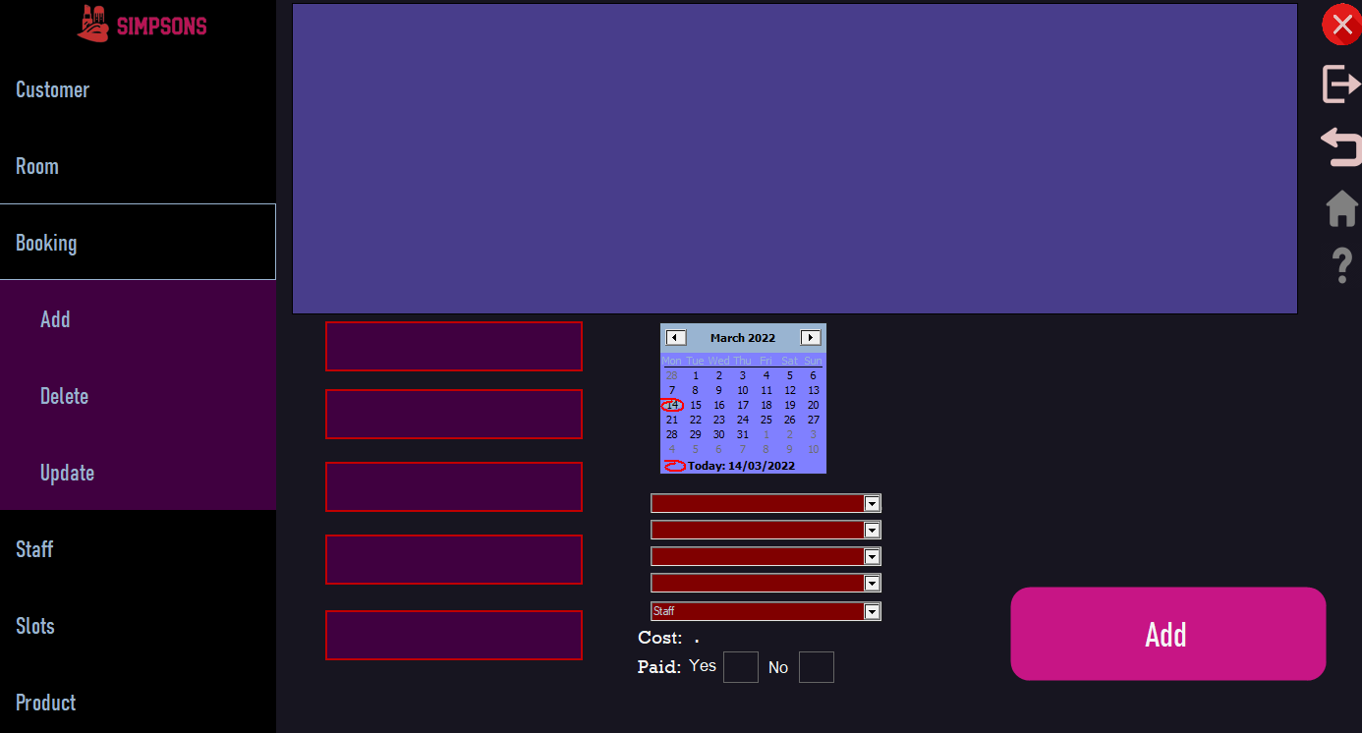

The user must click the “Add” button to gain access to the Booking form

Or the user can access the Booking form by clicking on “Add Booking” found within the content bar inside the Main Menu form.

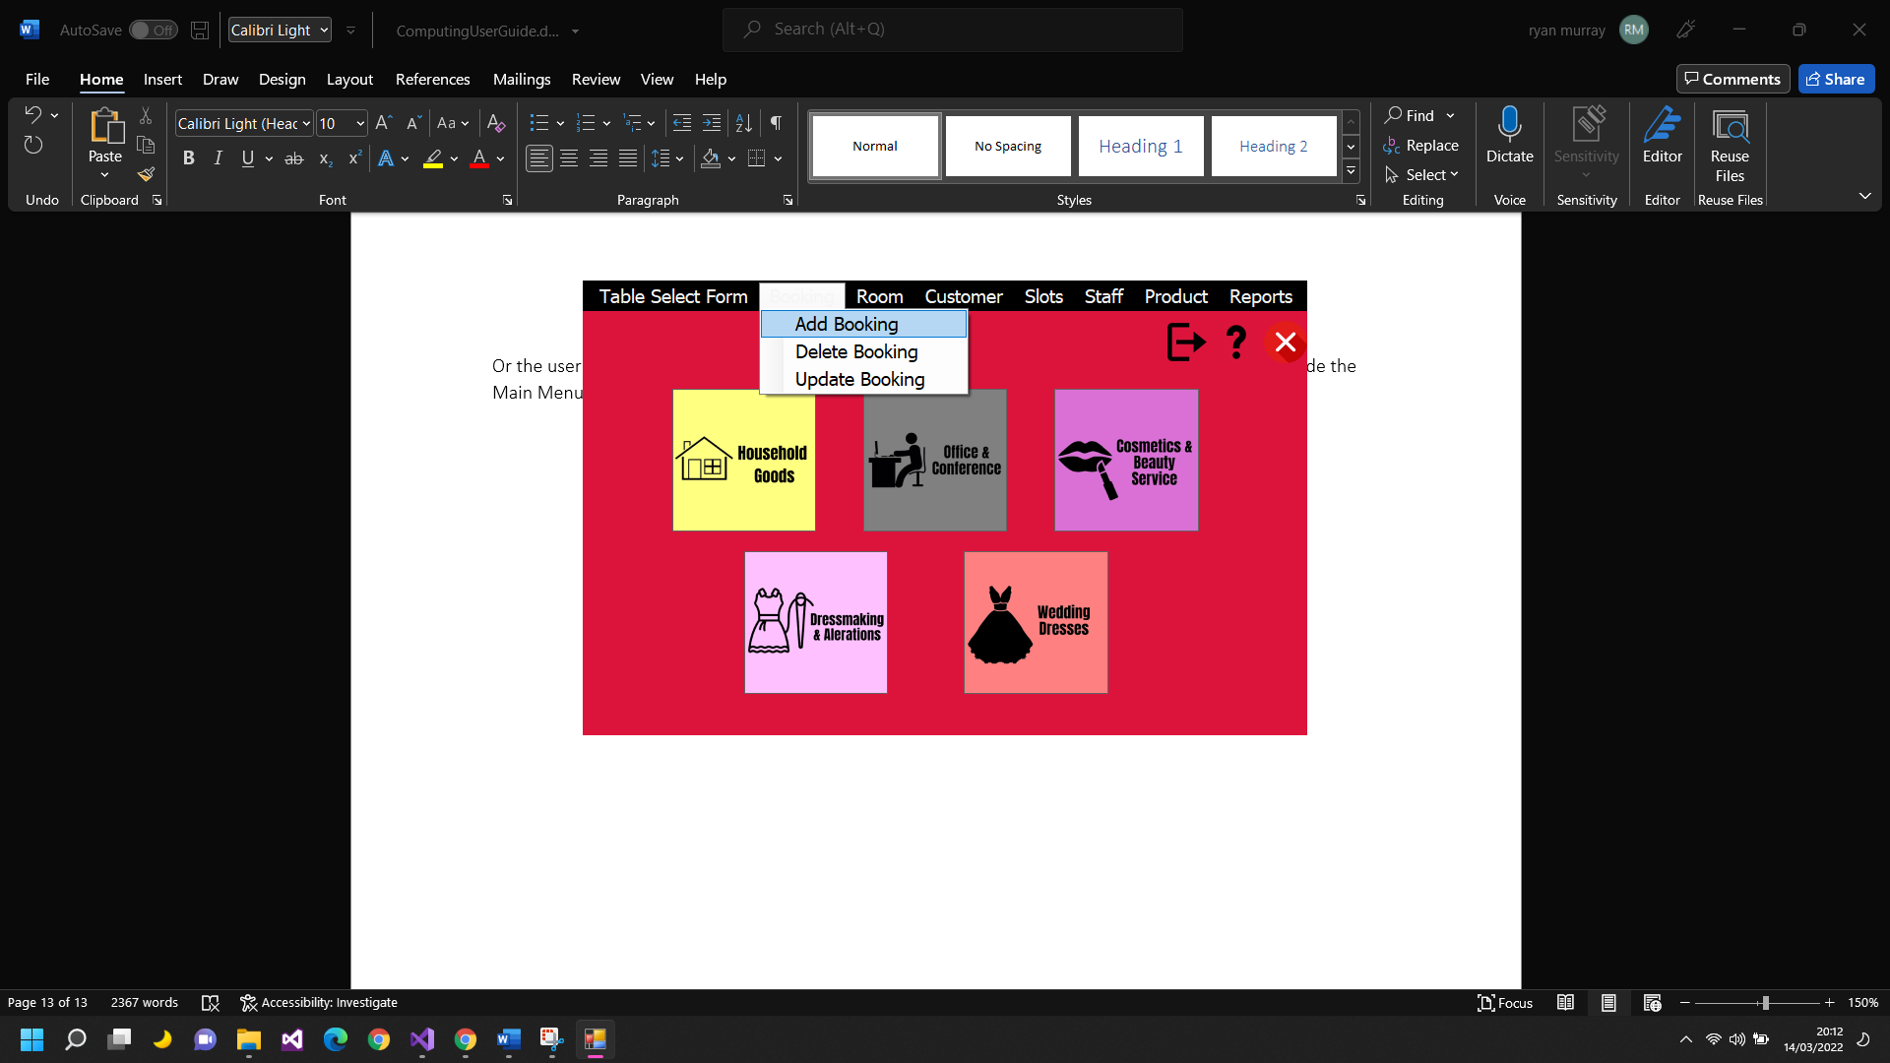

For the user to add a Booking, they must select a date then a slot time. The date is automatically set to the current date and any previous date cannot be set as bookings can only be made in the future. If a user fails to select a Slot Time they will be presented with a message box to remind them to select a time before attempting to search for slots.

Once the user selects a time slot and clicks the “Search” bar they will be presented with a loading gif to make the system engaging whilst also maintaining a professional feel.

Once the gif has stopped playing, a list of Rooms will be available for the user to choose from and upon selecting, the user will then be able to select a Staff member, as it is locked because some staff members may not be available.

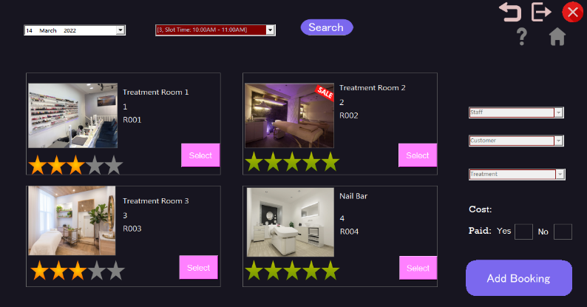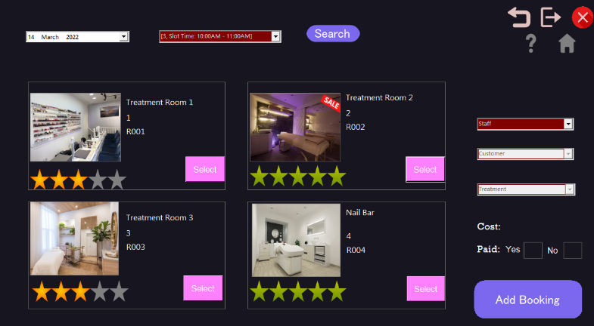

The user must click on a button, to choose the room they desire to book

Once the user has selected their room of choice, they must use the combo box to select a Staff member. Once the user has selected the Staff member, the Customer combo box will be available for use.

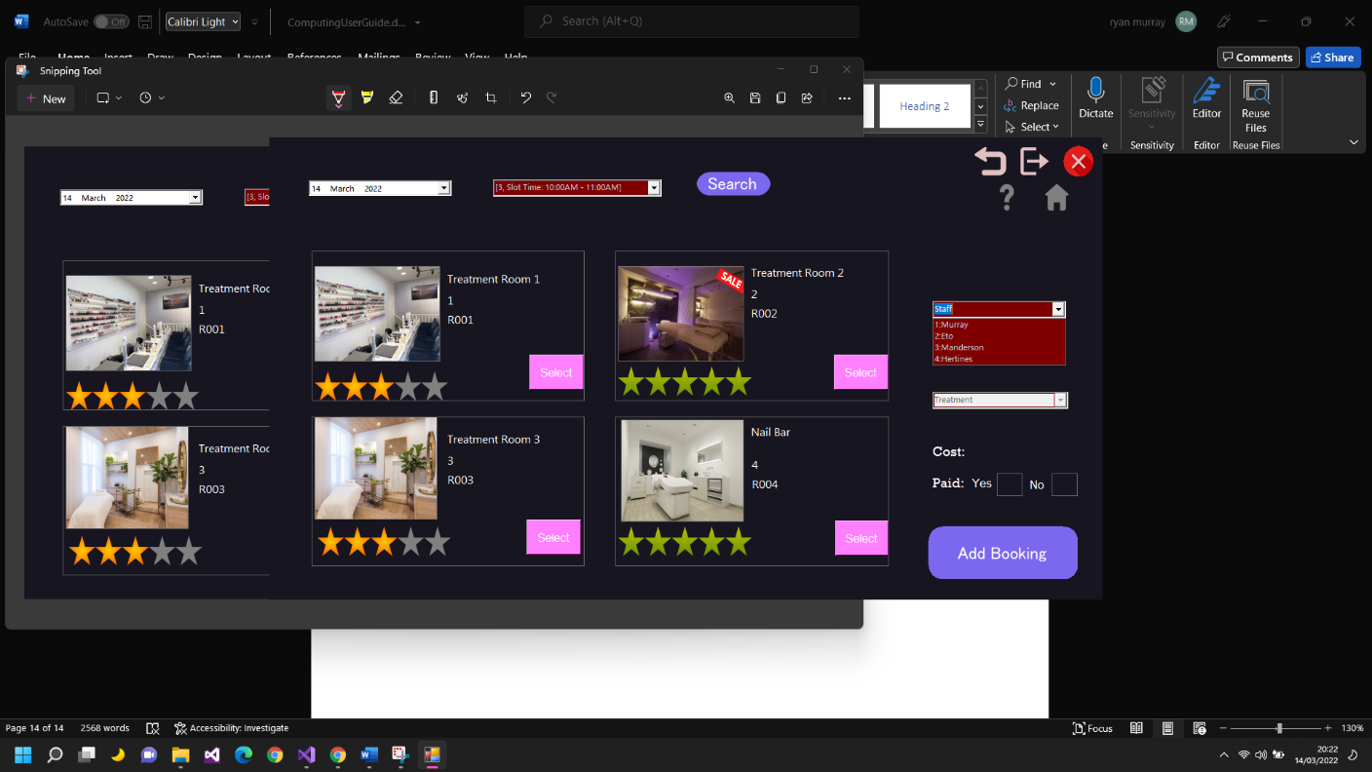

The user must select a Staff member using the Combo Box

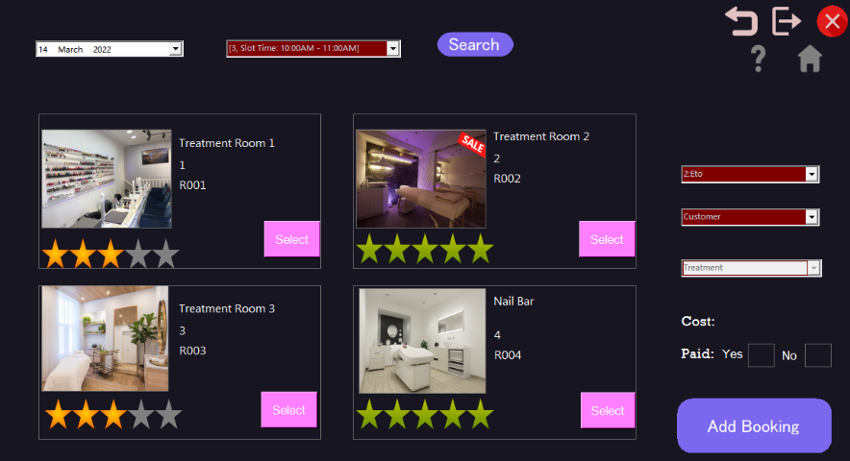

Like the Staff combo box, once the user has then selected their customer of choice, the Treatment Combo box will be available for use. Depending on what Room the user decides to book in, different treatments are then available and this is accessed throughout the combo box

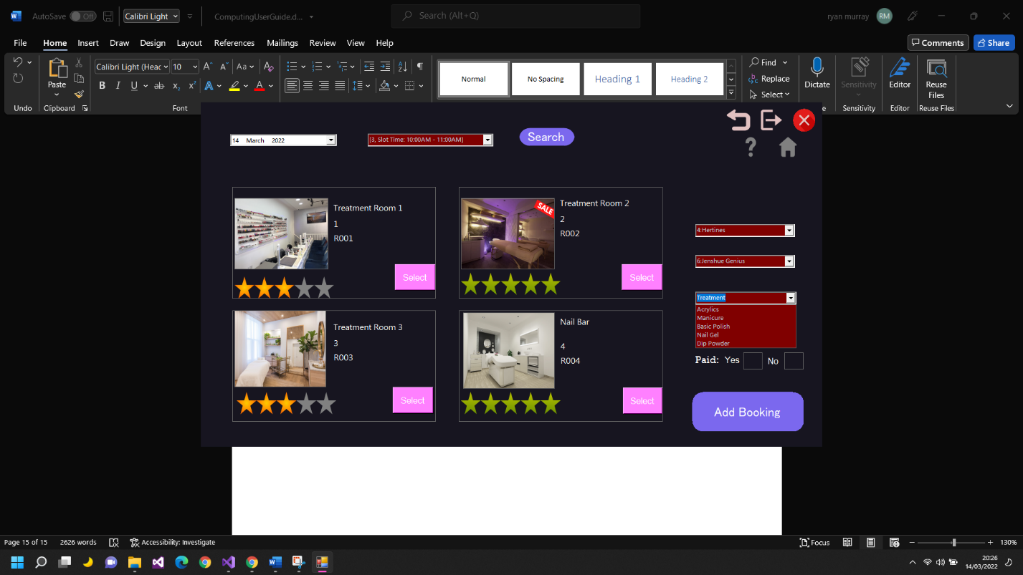

The following Treatments are available for the Nail Bar only

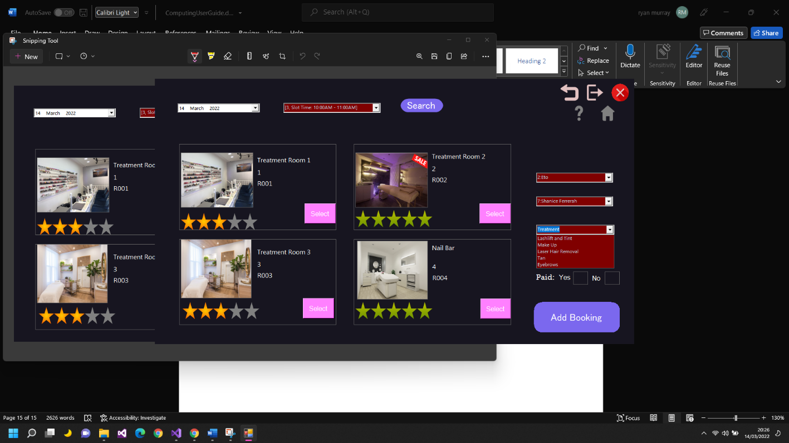

The following Treatments are available for the Treatment Rooms only

After the user has selected the Treatment of their choice they are presented with a Price for their Booking. The prices vary depending on what treatment the user selects and this is seen within a label.

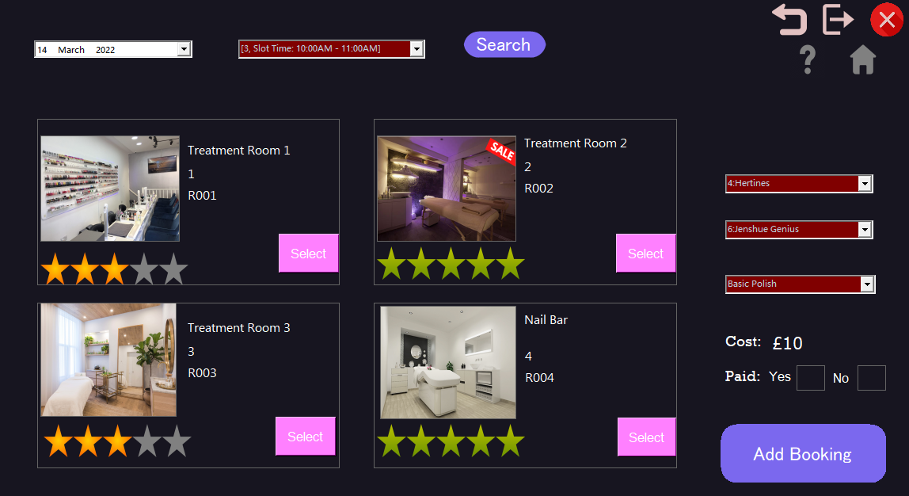

The Price can be seen here:

The final stages require the user to decide if they are wanting to Pay for the booking now, or later. The user must click on a picture box to enforce their decision. A Green tick is then visible inside the picture box the user clicks and if the user decides to change their mind, the picture then changes to the other picture box.

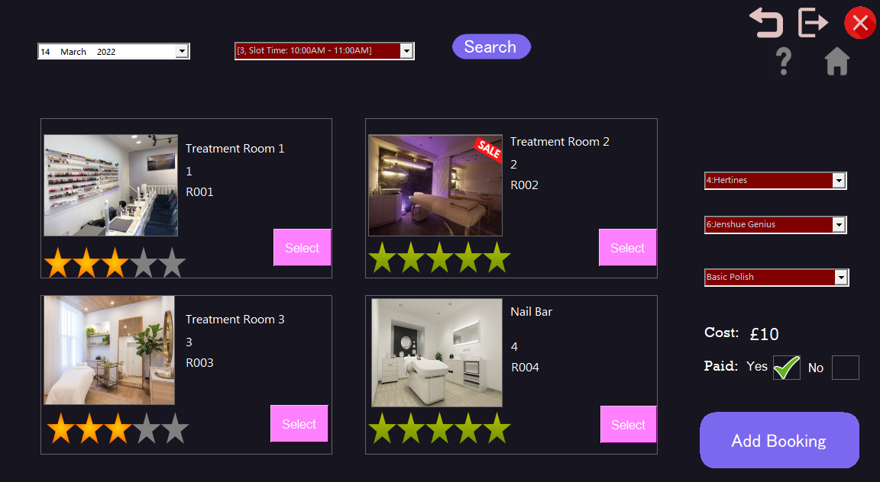

This is where the user selects if they are paying now or later

If the user changes their mind on what Room they want to use mid-process or the designated slot time, each combo box is then locked again and cleared as the following room may be booked out, or the previously selected Staff member may be booked. Although the date and slot time remain the same.

If the user decides to change the date for the Booking, the user will then be brought back to the starting stage of the form, where they must select a slot time to progress onto the next stage. This was put in place as the previous slot time may not be available for the new date selected.

If the user is wanting to make any edits to their Booking, this can be done via the Booking Update, found on the Simpsons Information form. (Once the user makes a booking, they will be redirected onto this form.

Updating a Booking is like the rest of the Update functions for each table as the user must select a row of information to Update before clicking on the “Update” button, although different controls are used such as a Month calendar to make it more efficient and easier to use for the user.

If the user is Updating a Booking and wants to change the Booking date the rest of the combo boxes, clear and change back to the default texts as the previous information such as Staff and Room may not be available for the next date.

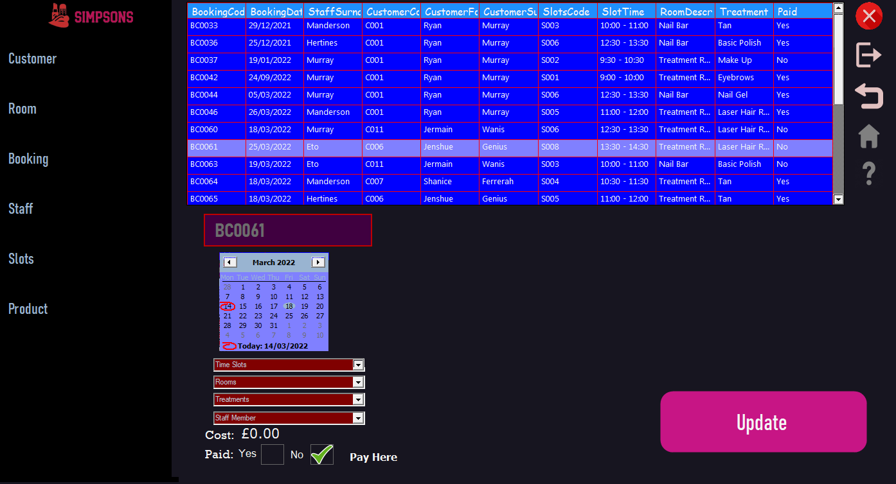

If the user changes the date, the text within each combo box changes

If the user is wanting to change their Room, the Treatment combo box is due to different treatments being available for different rooms. As well as the Treatment combo box clearing, the Price is also set back to “£0.00” as the user is required to select a treatment.

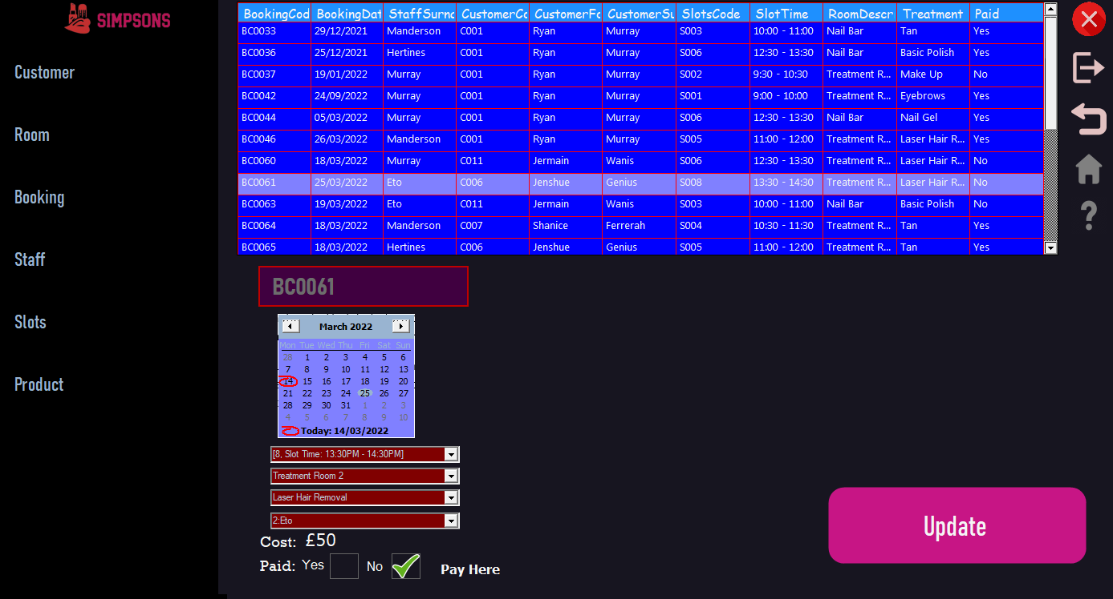

This shows when the user has not yet changed their room

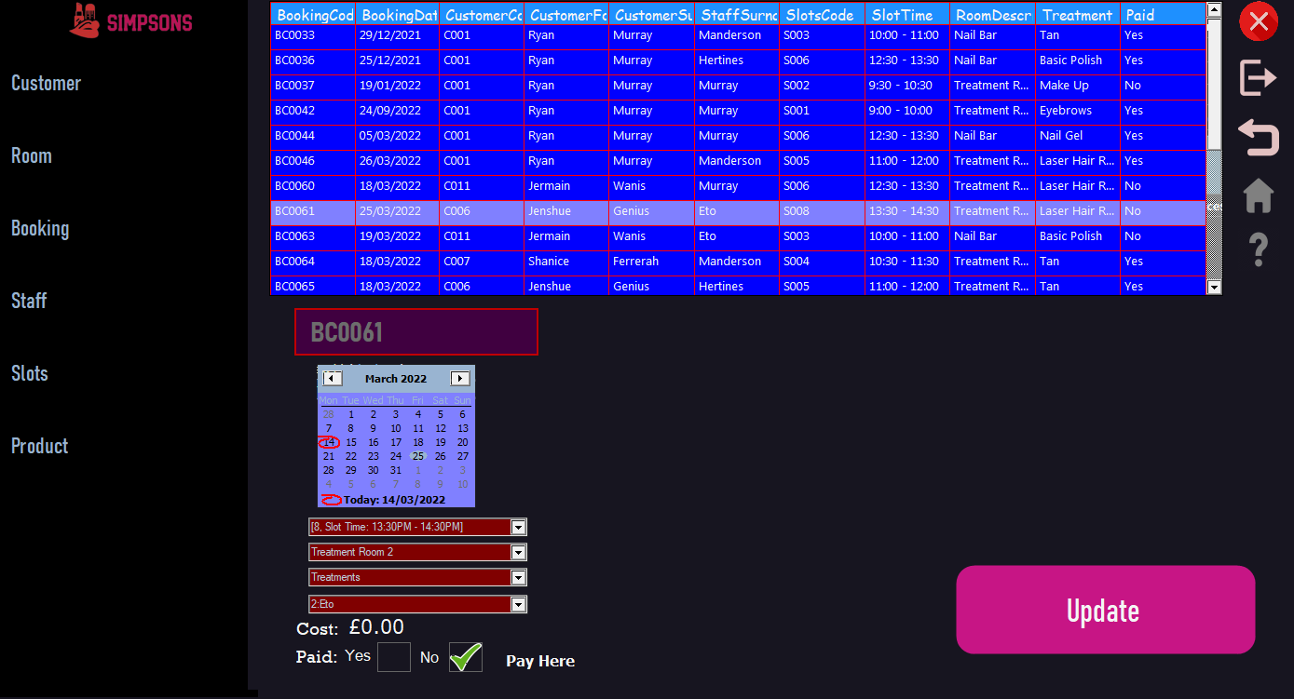

This shows when the user has changed their room